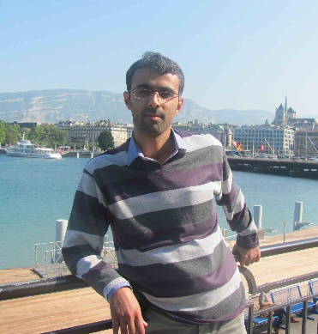
Mostafa Momeni
Birth: 1981
PhD in Strategic Management (2015)
Master of Business Administration (2007)
Assistant Professor of Management Faculty at Kharazmi University, Tehran, Iran
modir@mostafamomeni.ir

Susanne Balslev Nielsen
Birth: 1968
PhD in Planning (1998)
Associate Professor of Department of Engineering Management at Technical University of Denmark, Lyngby, Denmark
sbni@dtu.dk

The article name (in this case):
Impact of Personnel Capabilities on Organizational Innovation Capability

